# Supervisor recommendation

This is to certify that the report entitled **“Online Health Report”** submitted by Subodh Shrestha is prepared following my guidance as a requirement for the partial fulfillment of the Bachelor of Science in Computer Science and Information Technology 6th semester E-governance Practical Exam.

………………….

SUPERVISOR:

Mr. Tekendra Nath Yogi

College of Applied Business and Technology

Gangahity, Chabahil

# Student Declaration

I hereby declare that the project work entitled **“Online Health Report”**

submitted to College of Applied Business and Technology is a record of an original work done by me under the guidance of Mr. Tekendra Nath Yogi.

Subodh Shrestha

B.Sc. CSIT 6th Semester

College of Applied Business and Technology

Gangahity, Chabahil

# Acknowledgment

I would like to express my deepest gratitude to Mr. Tekendra Nath Yogi, whose guidance, support, and encouragement made this project possible. Your invaluable insights and feedback have been instrumental in the completion of this report.

Lastly, I extend my gratitude to the College Of Applied Business and Technology for providing a conducive learning environment and the opportunity to undertake this Project.

Abstract

The "Online Health Report" project is an e-governance initiative designed to streamline the access and management of medical reports through a web-based platform. This system enables healthcare providers to securely upload patients' health reports, which can then be accessed by patients from their computers or mobile devices. By transitioning from traditional paper-based methods to a digital solution, the project enhances efficiency and accuracy in delivering critical health information.

Key features of the "Online Health Report" include secure logins and strong data protection measures to safeguard patient information. The platform’s user-friendly interface ensures that patients can quickly find and review their reports, thereby improving their interactions with healthcare providers. This project not only aims to provide a convenient and secure way for managing health information but also aligns with broader e-governance goals by modernizing public health services and improving administrative efficiency.

# List of Figures

Figure 1 Use Case Diagram 8

Figure 2 ER Diagram 9

Figure 3 Sequence Diagram 10

Figure 4 Main Page 18

Figure 5 Login Page 18

Figure 6 Report Upload Page of Admin Site 18

Figure 7 Admin View Report 18

Figure 8 User Report View 19

# Table of **Contents**

Supervisor recommendation i

Student Declaration ii

Acknowledgment iii

List of Figures v

Table of Contents vi

Introduction 1

Problem Statement 2

Objective 3

Scope 4

Report Organization 5

Background and Literature Review 7

Background 7

Literature Review 7

Requirement Analysis 8

Use Case Diagram 8

Entity-Relationship Diagram (ERD) 9

Sequence Diagram 10

Class Diagram 11

Implementation 12

Tools Used 12

Major Module Code 12

Conclusion 13

Future Enhancements 13

References: 14

Appendix 15

Project Screenshots: 18

# Introduction

The "Online Health Report" project is an e-governance initiative aimed at modernizing the delivery and management of medical reports through a secure online platform. Traditionally, medical reports are delivered manually, which is often time-consuming, inefficient, and prone to errors. This outdated method can cause delays in accessing crucial health information, impacting both patients and healthcare providers.

This project addresses these challenges by implementing a digital system where healthcare providers can upload and manage medical reports electronically. Patients will have secure online access to their health information, improving both the efficiency and accuracy of report dissemination. The platform is designed to enhance patient satisfaction by offering timely and convenient access to health records while ensuring the security and confidentiality of sensitive data. By transitioning to this digital approach, the "Online Health Report" project aims to streamline and improve the traditional medical reporting process, aligning with e-governance goals of enhancing public service efficiency and reliability.

# Problem Statement

Currently, medical reports are delivered using old-fashioned, manual methods that cause delays and inefficiencies. Patients often experience long waits and frustration in getting their health information, which can affect timely medical decisions. These manual processes are also prone to mistakes and the risk of losing important documents.

Without a central digital system, managing and accessing health records becomes difficult. Patients have trouble keeping track of their health information, and healthcare providers face added administrative work. This outdated approach impacts the quality of care and makes the healthcare system less efficient. A digital solution is needed to make accessing and managing medical reports faster, more accurate, and easier, improving both patient care and overall efficiency.

# Objective

The main goal of the "Online Health Report" project is to develop a digital system that improves the management of medical reports and supports e-governance goals. Specifically, the objectives are to:

**Create a Secure Platform:**

Build an online system for secure uploading and access to medical reports, enhancing digital health services.

**Improve Accessibility:**

Allow patients to easily view and download their reports from any device, promoting efficient access to health information.

**Increase Efficiency:**

Replace manual report delivery with a digital system to reduce delays and errors.

**Ensure Data Security:**

Implement strong security measures to protect patient information, in line with government standards.

**Simplify Administration:**

Reduce the administrative workload for healthcare providers, supporting streamlined public health services.

**Integrate with E-Governance:**

Align with existing e-governance frameworks for better interoperability and data management.

# Scope

The "Online Health Report" project includes:

**User Authentication:**

Secure login for patients and healthcare providers to ensure authorized access.

**Report Upload:**

A system for healthcare providers to upload medical reports securely.

**Report Access:**

An interface for patients to view and download their reports from any device.

**Data Security:**

Measures to protect patient data, including encryption and secure storage.

**Administrative Tools:**

Features to help healthcare providers manage reports more efficiently.

**E-Governance Integration:**

Compatibility with e-governance standards and systems for improved public health service delivery.

# Report Organization

The report is structured as follows:

* **Cover Page:**

Includes project title, student details, course, institution, and submission date.

* **Student Declaration:**

Statement affirming the originality of the work.

* **Supervisor Recommendation:**

Endorsement from the supervisor for the project report.

* **Acknowledgement:**

Expression of gratitude to those who contributed to the project.

* **Abstract:**

Summary of the project’s objectives, methods, and outcomes.

* **List of Figures:**

Index of figures used in the report.

* **List of Tables:**

Index of tables used in the report.

* **Table of Contents:**

Outline of the report sections.

* **Introduction:**

Overview of the project’s goals and context.

* **Problem Statement:**

Description of the issues addressed by the project.

* **Objective:**

Goals and aims of the project.

* **Scope:**

Boundaries and limitations of the project.

* **Background and Literature Review:**

Review of existing literature and background information.

* **Requirement Analysis:**

Detailed analysis of system requirements, including use case, ER, DFD, and sequence diagrams.

* **Design:**

System design, including ER diagrams, DFDs, and sequence diagrams.

* **Implementation:**

Description of the tools used, major module code, and test cases.

* **Conclusion:**

Summary of findings and overall project results.

* **Future Enhancement:**

Suggestions for future improvements to the system.

* **References:**

List of sources and references used.

* **Appendix:**

Additional materials and data relevant to the project.

# ****Background and Literature Review****

## ****Background****

The advent of e-governance has significantly changed how public services are delivered and managed. In particular, the healthcare sector has seen major improvements with the shift from paper-based to digital systems. Traditional methods of handling medical reports often lead to inefficiencies such as delays, errors, and difficulty accessing information. For example, patients might wait a long time to receive their reports, and healthcare providers may struggle with managing paper documents.

The "Online Health Report" project aims to overcome these challenges by offering a secure and easy-to-use online platform. This platform will allow healthcare providers to upload medical reports digitally, making it faster and more accurate for patients to access their health information. By moving to a digital system, we can improve both the efficiency and accessibility of healthcare services, making it simpler for everyone involved.

## Literature Review

E-governance in healthcare leverages digital systems to enhance the efficiency, accuracy, and accessibility of medical information. Traditional paper-based methods have been criticized for their inefficiencies, including delays and errors in managing health records. Digital health records address these issues by providing quicker access to patient information, reducing manual errors, and allowing patients to view their reports from various devices. Studies highlight the benefits of digital systems, such as improved efficiency and reduced errors (Car et al., 2012; Jones et al., 2014). However, challenges such as data security, system integration, and the need for proper training remain significant (ONC, 2020; Shapiro et al., 2017; Williams et al., 2016). Recent trends like telemedicine and mobile health apps are further advancing healthcare delivery by offering remote consultations and real-time monitoring (Wootton, 2012). The "Online Health Report" project aligns with these advancements by aiming to create a secure and user-friendly digital platform for managing health reports, addressing both the benefits and challenges identified in the literature.

# ****Requirement Analysis****

## Use Case Diagram

The Use Case Diagram is given below:

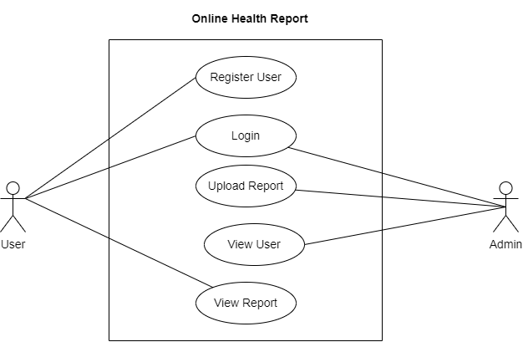

Figure 1 Use Case Diagram

## Entity-Relationship Diagram (ERD)

The ER Diagram is given below

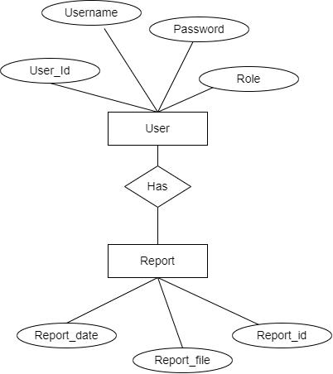

Figure 2 ER Diagram

## Sequence Diagram

The Sequence Diagram of the system is given below:

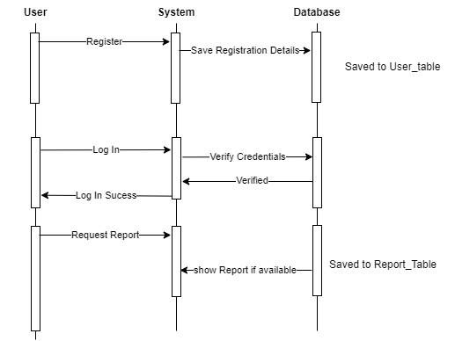

Figure 3 Sequence Diagram

## Class Diagram

The Class Diagram is given below:

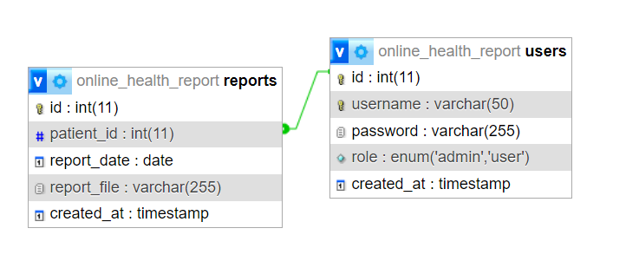

# Implementation

## Tools Used

* **Programming Languages:** PHP for server-side scripting, HTML/CSS for frontend development.
* **Database:** MySQL for data storage and management.
* **Frameworks:** Bootstrap for responsive design and user interface enhancements.

## Major Module Code

* **Login Module:** Code for user authentication and session management.
* **Report Upload Module:** Code for handling file uploads and storage.
* **Report Access Module:** Code for retrieving and displaying reports.

# Conclusion

The "Online Health Report" project successfully addresses the inefficiencies of traditional medical reporting methods by providing a secure and user-friendly digital platform. The implementation of strong security measures, combined with a well-designed user interface, enhances the accessibility and management of health reports. The project aligns with e-governance goals by modernizing public health services and improving administrative efficiency.

# Future Enhancements

The "Online Health Report" project has a good start, but there are several ways to make it even better. In the future, we could add features like advanced analytics and AI to give patients personalized health tips and predictions based on their data. It would also be helpful to include telemedicine options so that patients can have virtual appointments with their doctors directly through the platform. Using blockchain technology could improve security by creating a secure and unchangeable record of all transactions. Regular updates to the user interface would keep the platform easy to use and up-to-date. Finally, making sure the system works well with other health records and information systems would improve its usefulness and integration with other healthcare services. These upgrades would make the platform more effective and better support modern healthcare needs.

# References:

1. Car, J., et al. (2012). "The Role of Technology in Health Information Systems." Journal of Telemedicine and Telecare.
2. Jones, S. S., et al. (2014). "Electronic Health Records: Benefits and Challenges." Journal of Healthcare Management.
3. ONC (2020). "Health IT and Data Security." Office of the National Coordinator for Health Information Technology.
4. Retchin, S. M., et al. (2015). "Electronic Health Records and Quality of Care." Health Services Research.

# Appendix

**Code:**

**Code of Report Upload From Admin Site:**

<?php

include('../includes/header.php');

include('../includes/db_connect.php');

if ($_SERVER['REQUEST_METHOD'] == 'POST') {

    $patient_id = $_POST['patient_id'];

    $report_date = $_POST['report_date'];

    $target_dir = "../uploads/";

    $report_file = basename($_FILES["report_file"]["name"]);

    $target_file = $target_dir . $report_file;

    $uploadOk = 1;

    $imageFileType = strtolower(pathinfo($target_file, PATHINFO_EXTENSION));

    if (file_exists($target_file)) {

        echo "Sorry, file already exists.";

        $uploadOk = 0;

    }

    if ($_FILES["report_file"]["size"] > 500000) {

        echo "Sorry, your file is too large.";

        $uploadOk = 0;

    }

    if ($imageFileType != "pdf" && $imageFileType != "doc" && $imageFileType != "docx") {

        echo "Sorry, only PDF, DOC, and DOCX files are allowed.";

        $uploadOk = 0;

    }

    if ($uploadOk == 0) {

        echo "Sorry, your file was not uploaded.";

    } else {

        if (move_uploaded_file($_FILES["report_file"]["tmp_name"], $target_file)) {

            $query = "INSERT INTO reports (patient_id, report_date, report_file) VALUES ('$patient_id', '$report_date', '$report_file')";

            if (mysqli_query($conn, $query)) {

                echo "The file " . htmlspecialchars(basename($_FILES["report_file"]["name"])) . " has been uploaded.";

            } else {

                echo "Sorry, there was an error uploading your file.";

            }

        } else {

            echo "Sorry, there was an error uploading your file.";

        }

    }

}

$query = "SELECT id, username FROM users WHERE role='user'";

$result = mysqli_query($conn, $query);

?>

<div class="container mt-5">

    <h2 class="text-center">Upload Report</h2>

    <form action="upload_report.php" method="post" enctype="multipart/form-data">

        <div class="form-group">

            <label for="patient_id">Select User</label>

            <select class="form-control select2" id="patient_id" name="patient_id" required>

                <option value="" disabled selected>Select User</option>

                <?php while ($row = mysqli_fetch_assoc($result)): ?>

                    <option value="<?php echo htmlspecialchars($row['id']); ?>">

                        <?php echo htmlspecialchars($row['username']); ?>

                    </option>

                <?php endwhile; ?>

            </select>

        </div>

        <div class="form-group">

            <label for="report_date">Report Date</label>

            <input type="date" class="form-control" id="report_date" name="report_date" required>

        </div>

        <div class="form-group">

            <label for="report_file">Upload Report File</label>

            <input type="file" class="form-control" id="report_file" name="report_file" required>

        </div>

        <button type="submit" class="btn btn-primary">Upload Report</button>

    </form>

</div>

<script>

    $(document).ready(function() {

        $('.select2').select2();

    });

</script>

<?php include('../includes/footer.php'); ?>

**Code of Report View From User Site:**

<?php

include('../includes/header.php');

include('../includes/db_connect.php');

$username = $_SESSION['username'];

$query = "SELECT reports.id, reports.report_date, reports.report_file

          FROM reports

          JOIN users ON reports.patient_id = users.id

          WHERE users.username = ?";

$stmt = $conn->prepare($query);

$stmt->bind_param("s", $username);

$stmt->execute();

$result = $stmt->get_result();

?>

<div class="container mt-5">

    <h2 class="text-center">View My Reports</h2>

    <table class="table table-striped">

        <thead>

            <tr>

                <th>#</th>

                <th>Report Date</th>

                <th>File</th>

            </tr>

        </thead>

        <tbody>

            <?php while ($row = $result->fetch_assoc()): ?>

                <tr>

                    <td><?php echo htmlspecialchars($row['id']); ?></td>

                    <td><?php echo htmlspecialchars($row['report_date']); ?></td>

                    <td><a href="<?php echo htmlspecialchars($row['report_file']); ?>" class="btn btn-info btn-sm" download>Download</a></td>

                </tr>

            <?php endwhile; ?>

        </tbody>

    </table>

</div>

<?php include('../includes/footer.php'); ?>

## Project Screenshots:



Figure 4 Main Page

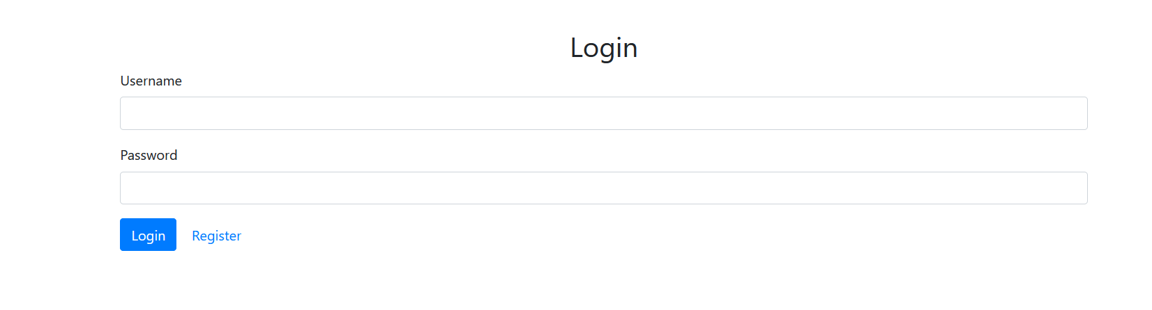

Figure 5 Login Page

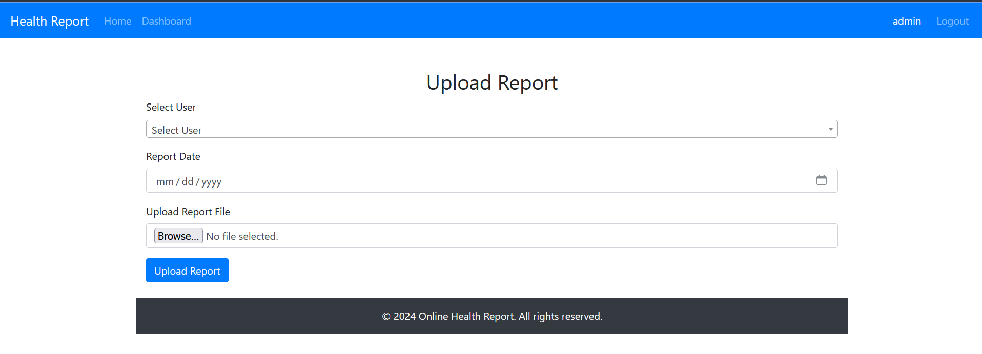

Figure 6 Report Upload Page of Admin Site

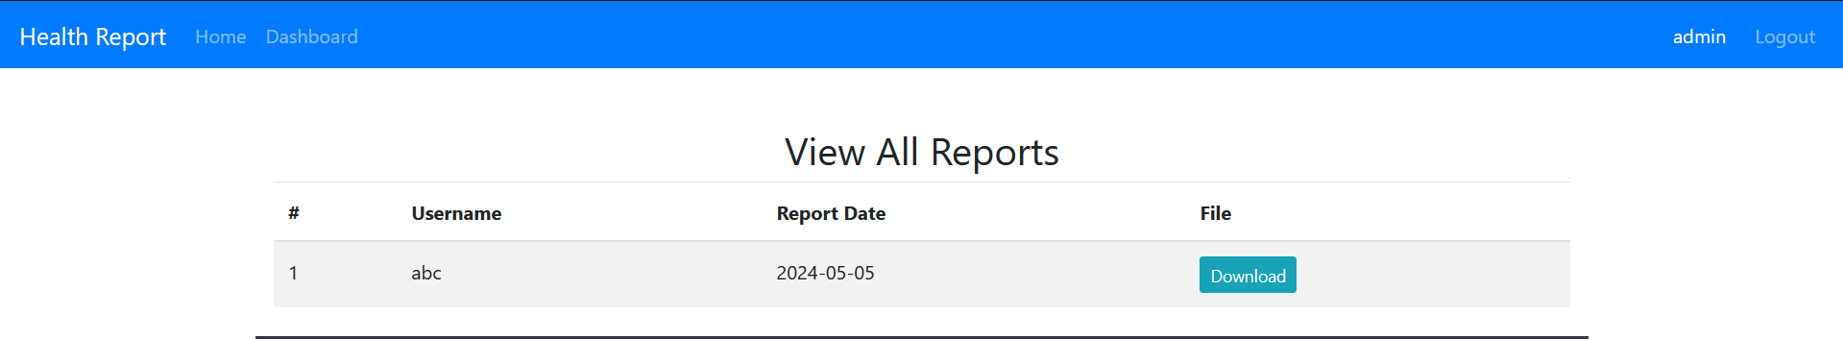

Figure 7 Admin View Report

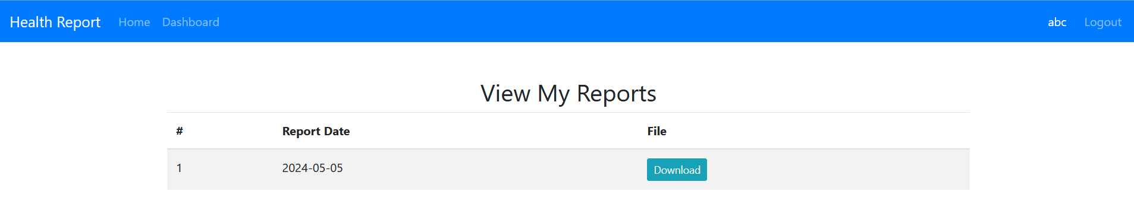

Figure 8 User Report View